My project focuses on analyzing and making inferences on “United States National Occupational Employment and Wage Estimates”.

Data

The data for this project has been downloaded from “Bureau Of Labor Statistics” website - https://www.bls.gov/bls/blswage.htm

National Employment and Wage Estimates – “National_salary.xls”

State wise Employment and Wage Estimates – “state_May2015_dl”

This data has the Employment and Wage estimates for the following major occupational groups:

* Management Occupations
* Business and Financial Operations Occupations
* Computer and Mathematical Occupations
* Architecture and Engineering Occupations
* Life, Physical, and Social Science Occupations
* Community and Social Service Occupations
* Legal Occupations
* Education, Training, and Library Occupations
* Arts, Design, Entertainment, Sports, and Media Occupations
* Healthcare Practitioners and Technical Occupations
* Healthcare Support Occupations
* Protective Service Occupations
* Food Preparation and Serving Related Occupations
* Building and Grounds Cleaning and Maintenance Occupations
* Personal Care and Service Occupations
* Sales and Related Occupations
* Office and Administrative Support Occupations
* Farming, Fishing, and Forestry Occupations
* Construction and Extraction Occupations
* Installation, Maintenance, and Repair Occupations
* Production Occupations
* Transportation and Material Moving Occupations

Columns read from the National and State data files to draw inferences:

* Occupation Title
* Employment Count
* Annual Mean Wage
* Annual 10th percentile wage, 25th percentile, median (50th percentile) wage, 75th percentile wage, 90th percentile wage
* Level – Major , Detail
  + - Major – Computer & Mathematical Occupations
    - Detail –
      * Computer and Information Research Scientists
      * Information Security Analyst
      * Web Developer
      * Database Administrator

Additional Columns read from State wise data

* Location Quotient
  + - (The location quotient represents the ratio of an occupation’s share of employment in a given area to that occupation’s share of employment in the U.S. as a whole. )

**R code to list the national top paying occupations**

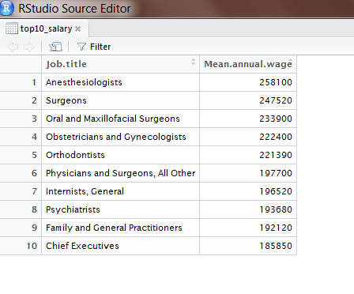

**R code to list the national lowest paying occupations**

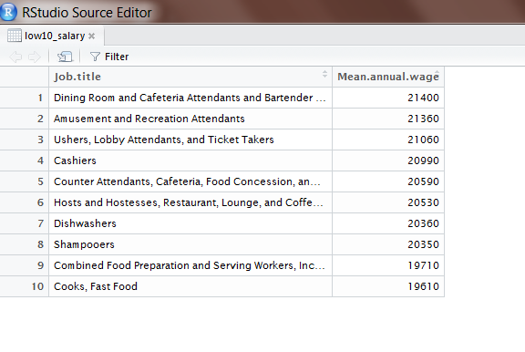

Box Plots to show Annual mean wage of 3 top paying occupations (Anesthesiologist, Chief Executives, Family and general practitioners) . The box plots are plotted with considering 10th percentile wage, 25th percentile, median (50th percentile) wage, 75th percentile wage and the 90th percentile wage.

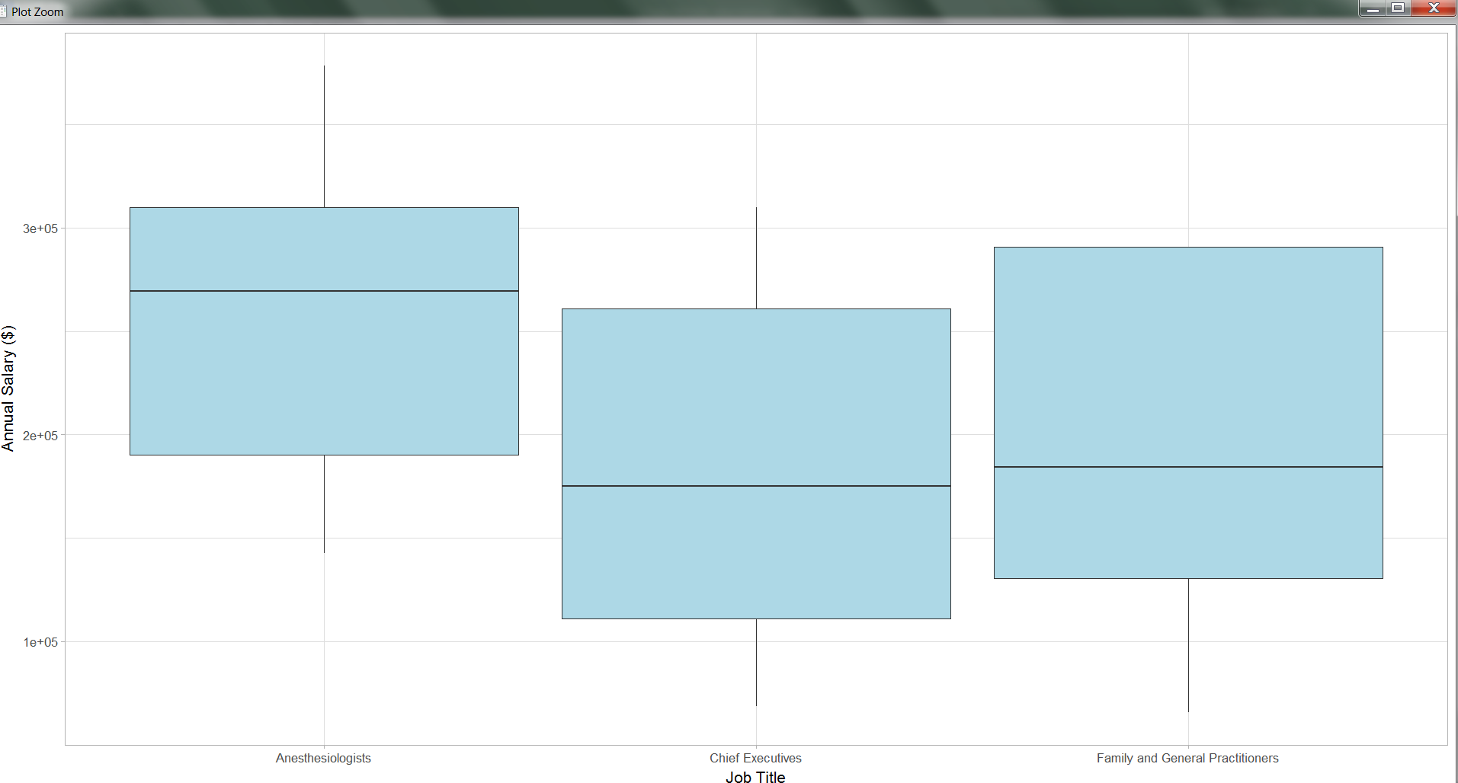

Box Plot for lowest paying occupations

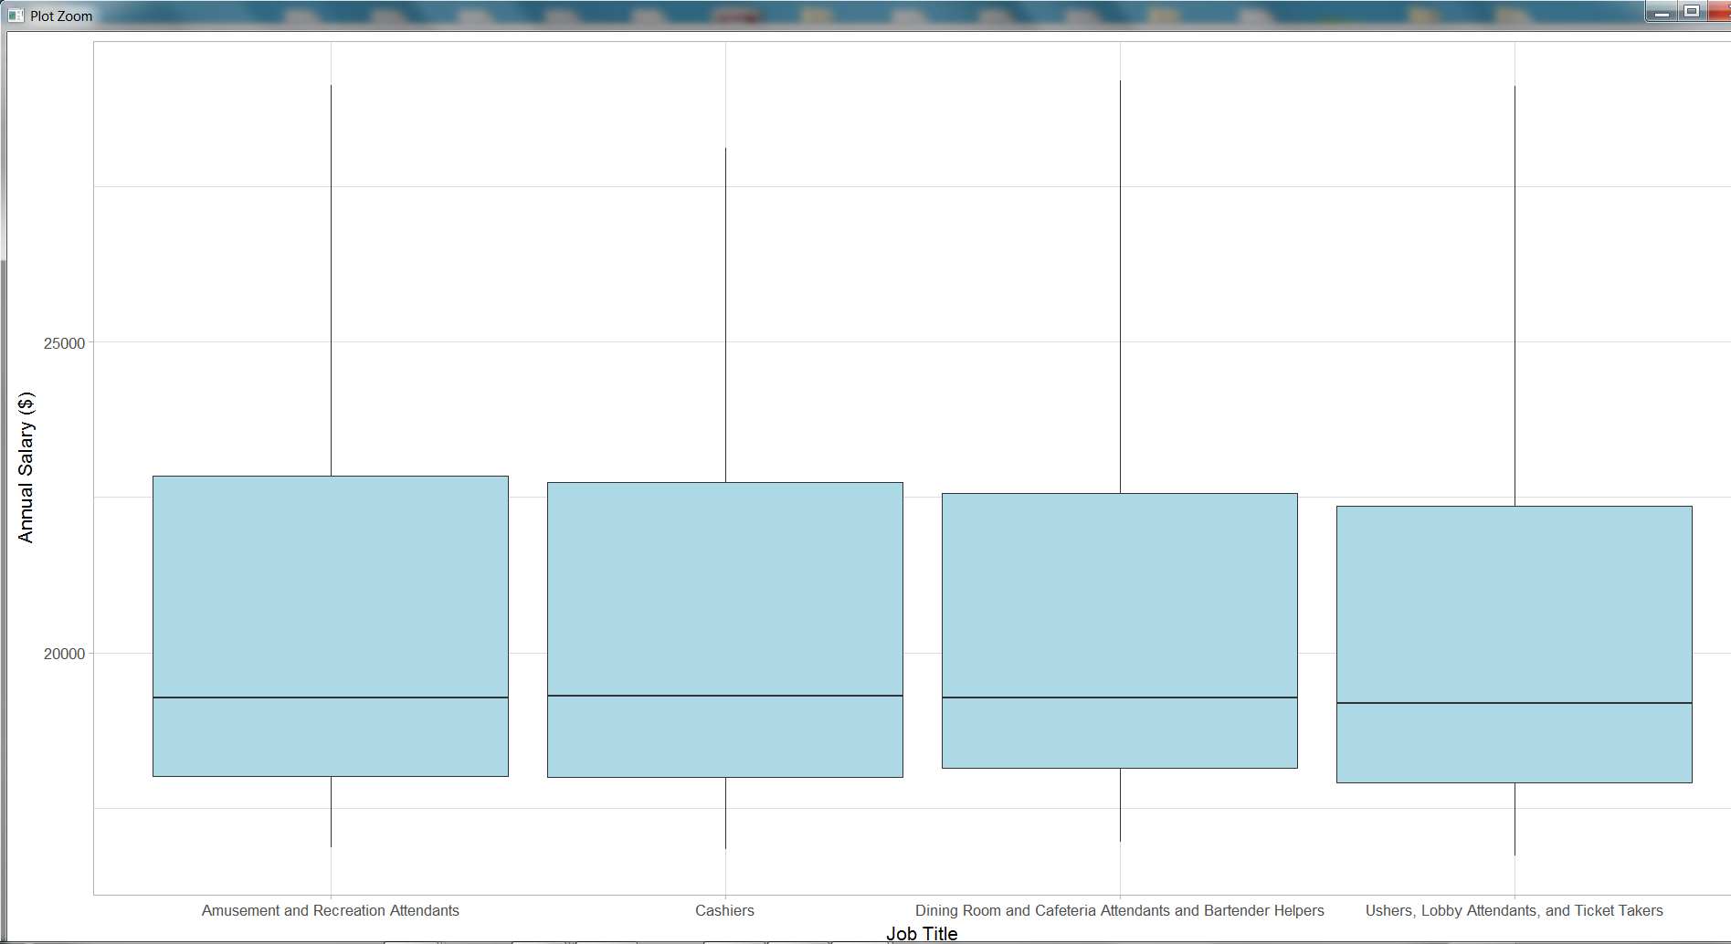

Density graph for Major Occupations (based on National data).

Salary range plotted on X-axis and Employment count plotted on Y-axis.

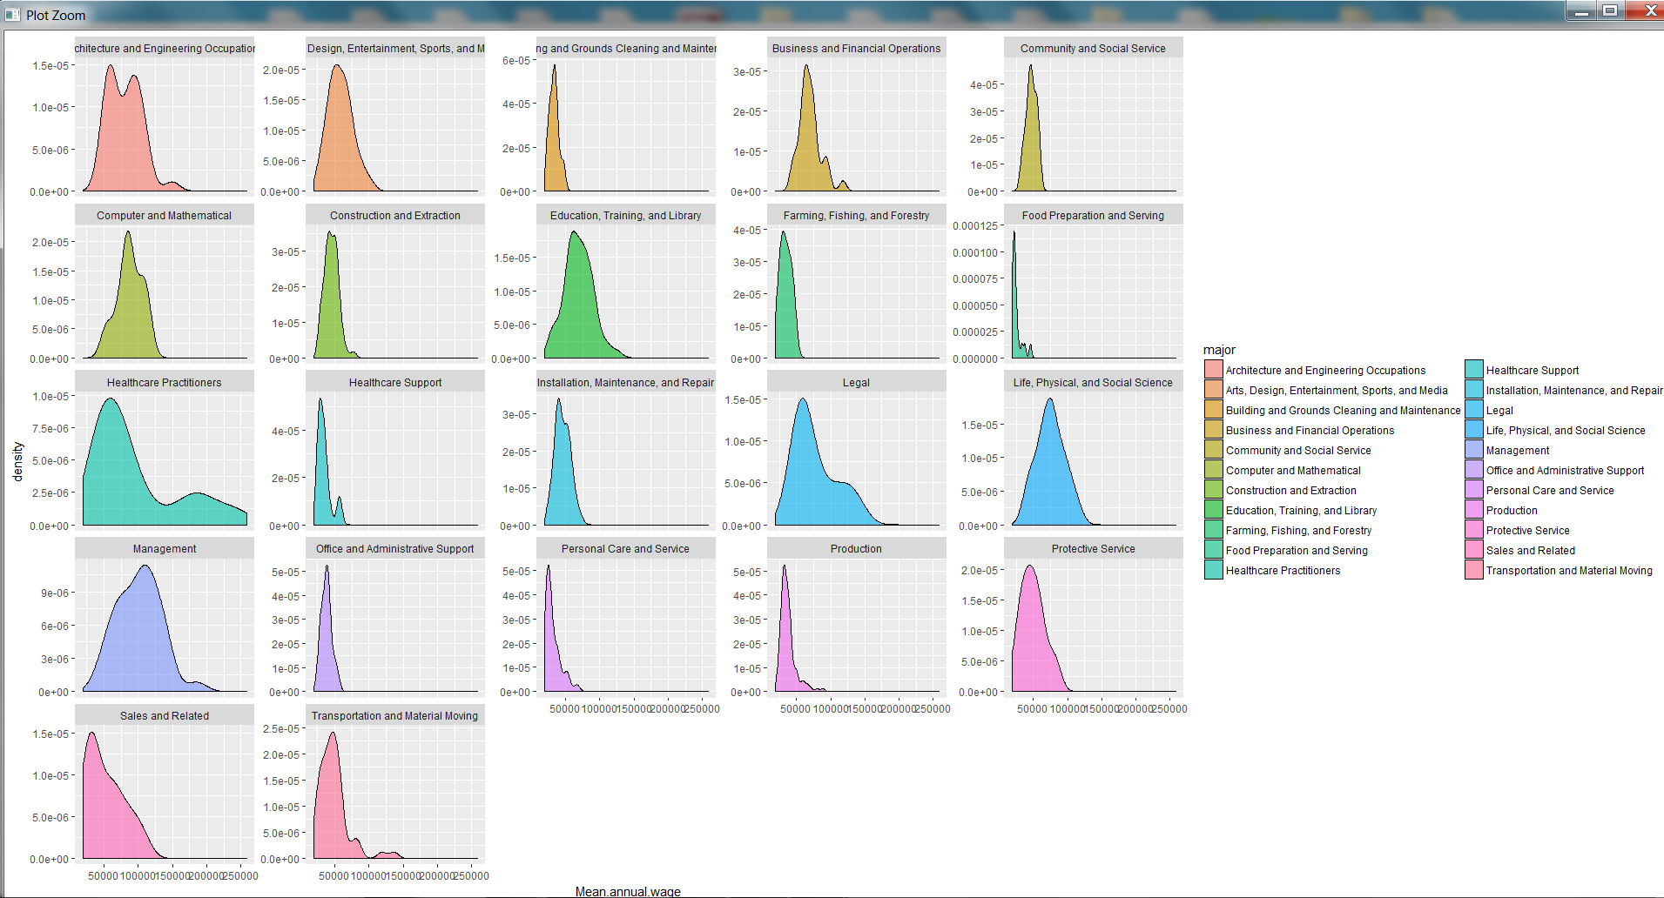

Healthcare Practitioners have certain practitioners earning salaries in the highest range > 300K.

Shiny app to

1. Select the Occupation type
2. Select the Choropleth map type – “Annual Wage or Location Quotient”
3. Plot the Horizontal bar graph to plot the Employment count by State & Occupation
4. Plot the State Choropleth map for Annual Mean Salary/ Location Quotient by State and Occupation

